**Date: 16-10-21**

**Experiment 7**

**Aim:** To work with MATLAB strings and additional data plots.

**Apparatus:** MATLAB Software

**Objective:**

1. To learn about different string operations.
2. To be aware of additional features of the simple two-dimensional plots.
3. To learn how to plot in three dimensions.

**Problems:**

**Q-1.** Write a program that accepts an input string from the user and determines the how many times a user-specified character appears within the string. (*Hint:* Look up the 's' option of the input function using the MATLAB Help Browser.)

**Code:**

clc;

clear all;

close all;

str = input("\nEnter Your String: ",'s');

alph = input("\nEnter your desired Letter: ",'s');

fprintf("\nCount: %d",count(str,alph));

**Output:**

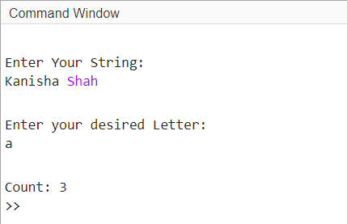

**Q-2.** Modify the previous program so that it determines how many times a user-specified character appears within the string without regard to the case of the character.

**Code:**

clc;

clear all;

close all;

str = input("\nEnter Your String: ",'s');

alph = input("\nEnter your desired Letter: ",'s');

fprintf("\nCount: %d",count(str,alph,'IgnoreCase',true));

**Output:**

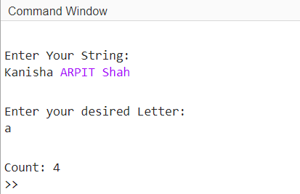

**Q-3.** Write a program that accepts a string from a user with the input function, chops that string into a series of tokens, sorts the tokens into ascending order, and prints them out.

**Code:**

clc;

clear all;

close all;

%First Way

str = input("\nEnter Your String: ",'s');

x = convertStringsToChars(str);

as = sort(x);

fprintf("\n1. Sorted Character String: %s",as);

%Second Way

str = input("\n\n\nEnter Your String: ",'s');

x = split(lower(str));

fprintf("\n2. Sorted Character String:\n");

s = sort(x);

disp(s);

**Output:**

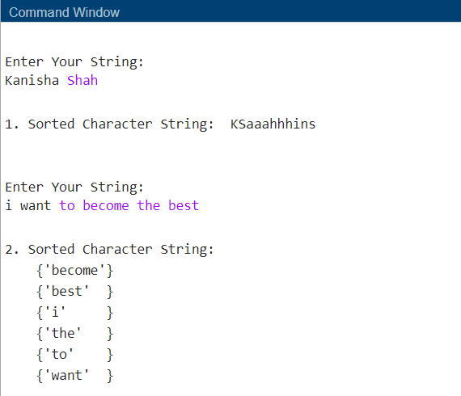

**Q-4.** MATLAB includes functions upper and lower, which shift a string to upper case and lower case respectively. Create a new function called caps, which capitalizes the first letter in each word and forces all other letters to be lower case. (*Hint:* Take advantage of functions upper, lower, and strtok.)

**Code:**

% clc;

% clear all;

% close all;

%First Way

function Question4

str = input("\nEnter Your String: ",'s');

output = caps(lower(str));

fprintf("\nCapitalised String: %s",output);

end

function str = caps(str)

str(1)=upper(str(1));

for i=1:length(str)

if(str(i)==' ')

str(i+1)=upper(str(i+1));

end

end

end

**Output:**

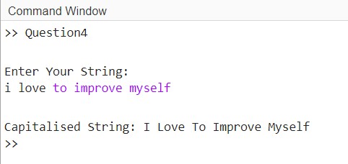

**Q-5.** Write a function that accepts a character string and returns a logical array with true values corresponding to each printable character that is *not* alphanumeric or whitespace (for example, $, %, #, etc.) and false values everywhere else.

**Code:**

% clc;

% clear all;

% close all;

%First Way

function Question5

str = input("\nEnter Your String: ",'s');

n = ones(1,strlength(str));

for i = 1:strlength(str)

if (isstrprop(str(i), 'alphanum')==1 || isstrprop(str(i), 'wspace')==1)

n(1,i) = 0;

end

end

for i = 1:strlength(str)

if n(i) == 1

disp('True')

else

disp('False')

end

end

end

**Output:**

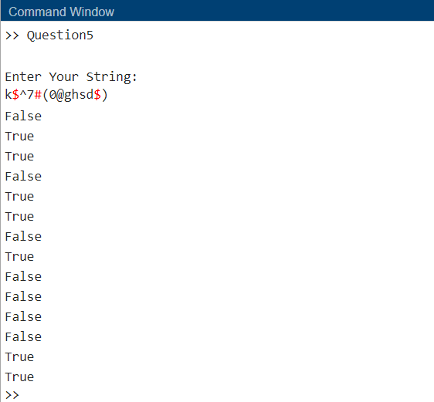

**Q-6.** Write a function that accepts a character string and returns a logical array with true values corresponding to each vowel and false values everywhere else. Be sure that the function works properly for both lowercase and uppercase characters.

**Code:**

function Question6

str =input("Enter string: ",'s');

a = isVowel(str);

for i = 1:strlength(str)

if a(i) == 1

disp('True')

else

disp('False')

end

end

end

function A = isVowel(instr)

A=[];

for i=char(instr)

A(end+1)=contains('aeiouAEIOU',i);

end

return

end

**Output:**

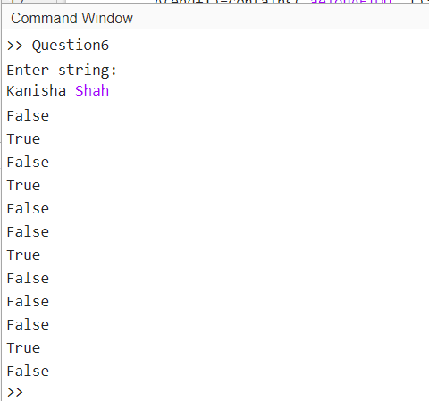

**Q-7.** Plot the function ${y=e}^{-x}\sin{x}$ for *x* between 0 and 2 in steps of 0.1. Create the following plot types: *(a)* stem plot; *(b)* stair plot; *(c)* bar plot; *(d)* compass plot. Be sure to include titles and axis labels on all plots.

**Code:**

clc;

clear all;

close all;

x=0:0.1:2;

y = exp(-x).*sin(x);

figure(1)

stem(x,y)

title('y v/s x')

xlabel('x')

ylabel('y')

figure(2)

stairs(x,y,"LineStyle","--","Color","red","LineWidth",1)

title('y v/s x')

xlabel('x')

ylabel('y')

figure(3)

bar(x,y)

title('y v/s x')

xlabel('x')

ylabel('y')

figure(4)

compass(x,y)

title('y v/s x')

xlabel('x')

ylabel('y')

**Output:**

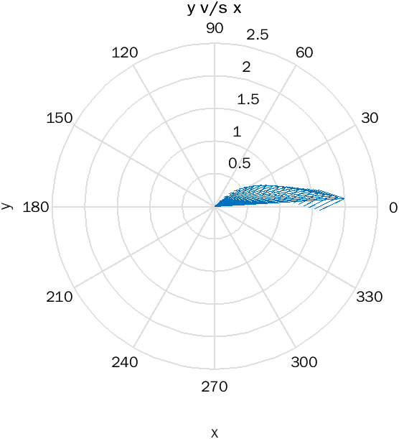

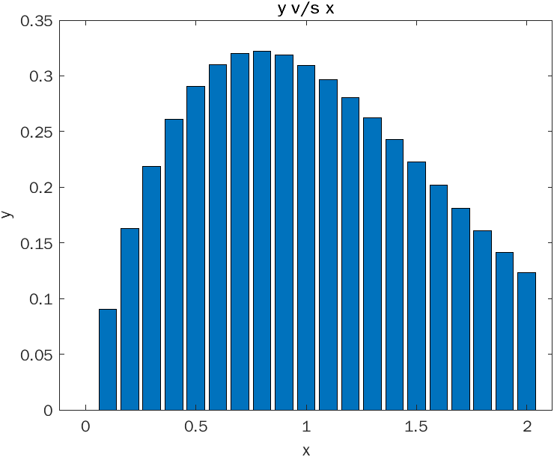

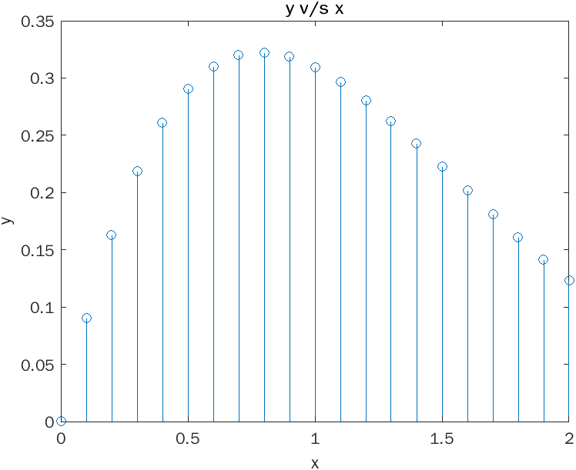

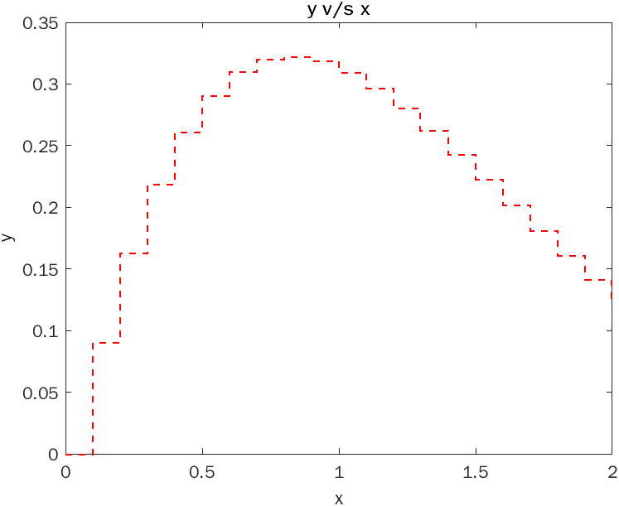

**Q-8.** Suppose that George, Sam, Betty, Charlie, and Suzie contributed $15, $5,$10, $5, and $15, respectively, to a colleague’s going-away present. Create a pie chart of their contributions. What percentage of the cost was paid by Sam?

**Code:**

clc;

clear all;

close all;

x=[15, 5, 10, 5, 15];

explode=[0, 1, 0, 0, 0];

labels={'George', 'Sam','Betty', 'Charlie', 'Suzie'};

pie(x, explode, labels)

n = (x(2)/sum(x))*100;

fprintf("Cost paid by Sam: %d",n);

**Output:**

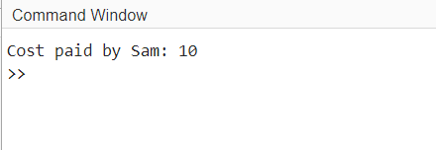

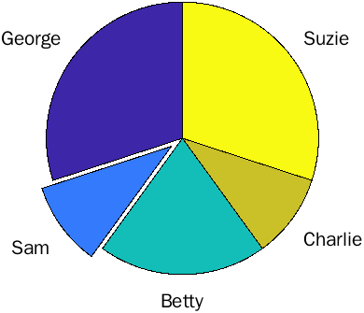

**Q-9.** Plot the function f(x)=1/ $√x$ over the range 0.1<=x<=10 using the function fplot. Be sure to label your plot properly.

**Code:**

clc;

clear all;

close all;

x=0.1:0.1:10;

y=1./sqrt(x);

fplot(y)

title('y=x^-^0^.^5')

xlabel('x')

ylabel('y')

**Output:**

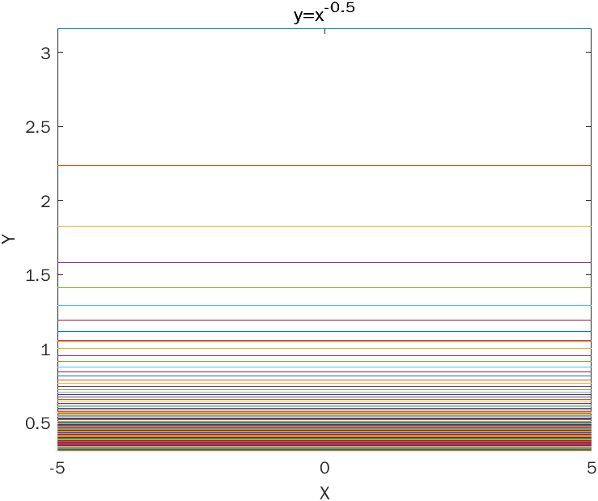

**Q-10.** Create a mesh, surface plot, and contour plot of the function ${z=e}^{x+iy}$ for the interval -1<=x<=1 and -2п<=y<=2п. In each case, plot the real part of *z* versus *x* and *y*.

**Code:**

clc;

clear all;

close all;

x = -1:0.1:1;

y = -2*pi:0.1:2*pi;

[x, y] = meshgrid(x, y);

z = exp(x + 1i * y);

figure(1)

mesh(x,y,real(z),'Linewidth',1);

title('Mesh');

xlabel('X');

ylabel('Y');

zlabel('Real(z)');

figure(2)

surf(x,y,real(z));

title('Surf');

xlabel('X');

ylabel('Y');

zlabel('Real(z)');

figure(3)

contour(x,y,real(z),'Linewidth',1);

title('Contour');

xlabel('X');

ylabel('Y');

zlabel('Real(z)');

**Output:**

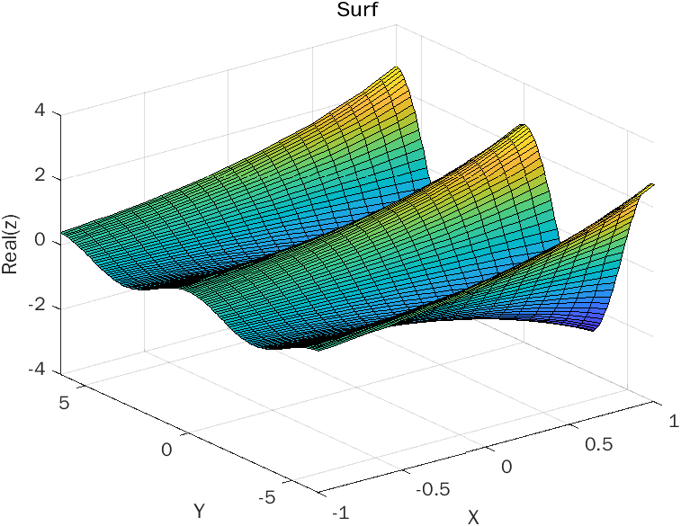

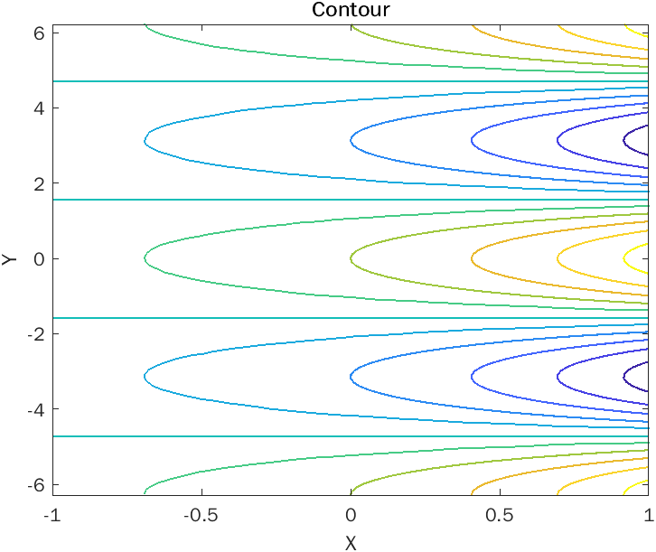

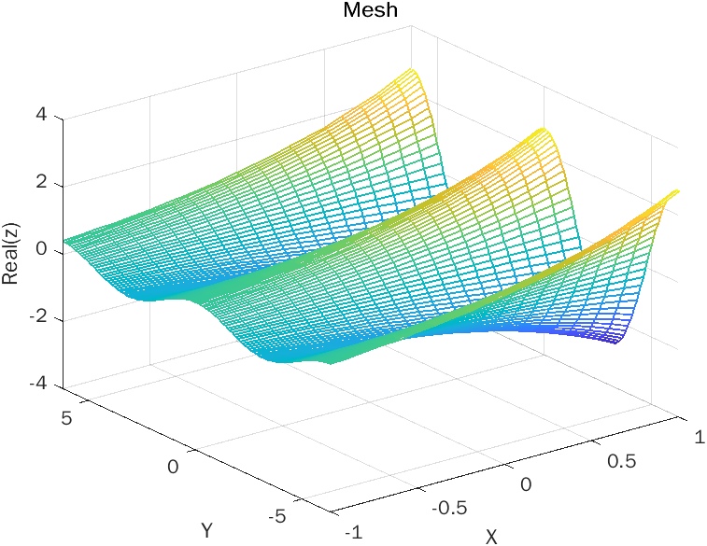

**Conclusion:**

From this experiment we came to learn different ways to plot 3D graphs, Pie Plots, Contour Plots, Mesh Plots, Stem, Function Plot, Stairs and many more. It was very helpful to learn the functions diagrammatically using the plots, certain basic concepts of graphs got clear using these plots.